**Unlocking the Power of Sentiment Analysis: A Deep Dive into Real-World Case Studies**

**S**entiment analysis has become a game-changer for businesses looking to understand their customers better and make data-driven decisions. By analysing customer feedback, reviews, and social media mentions, companies can gain valuable insights into how people perceive their brand, products, or services. In this Case study, we'll explore a fascinating sentiment analysis case study that demonstrate the power of this technology and how it's being applied across various industries.

**Table of Contents**

|  |  |  |
| --- | --- | --- |
| S. No | Topics | Page No |
| 1 | Understanding Sentiment Analysis | 2 |
| 2 | Sentiment Analysis in Action: Real-World Case study | 2 |
| 3 | Customer Review Analysis in the Restaurant Industry in Bangalore | 2-6 |
| 4 | Dilemma in the case | 6-8 |
| 5 | Best Practises for Implementing Sentiment Analysis | 9 |
| 6 | Conclusion | 9 |
| 7 | Appendix | 9-10 |
| 8 | Related Questions | 10 |

**Understanding Sentiment Analysis**

Before we dive into the case studies, let's take a moment to understand what sentiment analysis is and why it's so important. Sentiment analysis is a branch of natural language processing (NLP) that focuses on identifying and extracting subjective information from text data. It involves analysing the emotions, opinions, and attitudes expressed in a piece of text to determine whether the overall sentiment is positive, negative, or neutral.

Sentiment analysis can be performed at different levels, such as document-level, sentence-level, or aspect-level. Document-level sentiment analysis looks at the overall sentiment of an entire document, while sentence-level analysis examines the sentiment of individual sentences. Aspect-level sentiment analysis goes even further by identifying specific aspects or features mentioned in the text and determining the sentiment associated with each one.

**Sentiment Analysis in Action: Real-World Case Studies**

Now that we have a basic understanding of sentiment analysis, let's explore some real-world case studies that showcase its practical applications.

**Case Study: Customer Feedback Analysis in the Restaurants Industry**

The Restaurants industry heavily relies on customer feedback to improve service quality and Customer satisfaction. Sentiment analysis can play a crucial role in analysing customer reviews and feedback from various sources, such as food delivery platforms, social media, and feedback on google.

**Case Objective**

* **Broad Objective**: To leverage sentiment analysis on restaurant reviews to gain insights into customer preferences, satisfaction, and dissatisfaction across different cuisines in Bangalore. This analysis aims to assess the correlation between customer sentiments and average ratings to explore whether sentiment scores align with customer satisfaction as expressed through ratings.
* **Specific Goals**:
  + **Improve Service Quality**: Identify key pain points and positive highlights across different cuisines so that restaurant owners can tailor service improvements. For example, if sentiment analysis reveals common complaints about service in certain cuisines, management could focus on staff training or operational changes to address this.
  + **Informed Decision-Making for Marketing**: By understanding the sentiment associated with each cuisine, restaurants can adjust their marketing and promotion strategies to emphasize strengths or address weaknesses. For instance, cuisines with a high proportion of positive sentiment but low visibility can be marketed more heavily.
  + **Targeted Customer Experience Management**: Use sentiment-driven insights to personalize the dining experience for each cuisine. For example, a restaurant specializing in Italian cuisine might focus on enhancing the authenticity of dishes if positive sentiment is tied to traditional Flavors.
* **Expected Outcomes**: The case study expects to reveal actionable insights, such as specific cuisine trends and correlations between sentiments and ratings, offering restaurant management a blueprint for optimizing customer satisfaction through targeted improvements and data-driven strategies.

**Background**

* **Food Scene in Bangalore**: Bangalore is a cosmopolitan city known for its varied food culture. From traditional Indian cuisine to international offerings, each restaurant segment appeals to a unique customer base with diverse expectations. This vibrant food scene provides a great environment to study customer feedback across cuisines.
* **Dataset Overview**:
  + **Size and Scope**: The dataset comprises 42,000 reviews across various platforms, covering seven cuisines: South Indian, Italian, Chinese, North Indian, Desserts, Middle East, and Barbecue. Each review includes key columns like restaurant name, cuisine, review text, rating, and platform, as well as sentiment scores indicating positive, negative, neutral, and composite sentiments.
  + **Sentiment Analysis Approach**: Sentiment analysis has been applied to categorize reviews by sentiment scores. For instance:
    - **Positive Sentiment**: Represents reviews expressing high satisfaction, such as praising food quality or ambiance.
    - **Negative Sentiment**: Indicates areas of customer dissatisfaction, such as complaints about service or portion sizes.
    - **Neutral Sentiment**: Represents reviews that are neither strongly positive nor negative, possibly indicating moderate satisfaction or ambivalence.
    - **Composite Score**: Provides an overall measure by combining positive, negative, and neutral sentiments into a single sentiment index.
* **Relevance of Sentiment Data**: By analysing this data, the case study seeks to understand how these sentiments correlate with customer ratings, providing restaurants with insights to improve customer satisfaction at a cuisine-specific level.

**Outcomes from the Data**

**1.Sentiment Distribution**

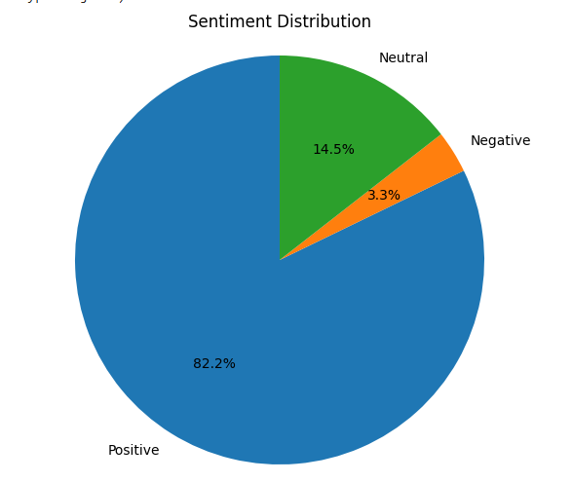

**3.Neutral Review Proportion by cuisine**

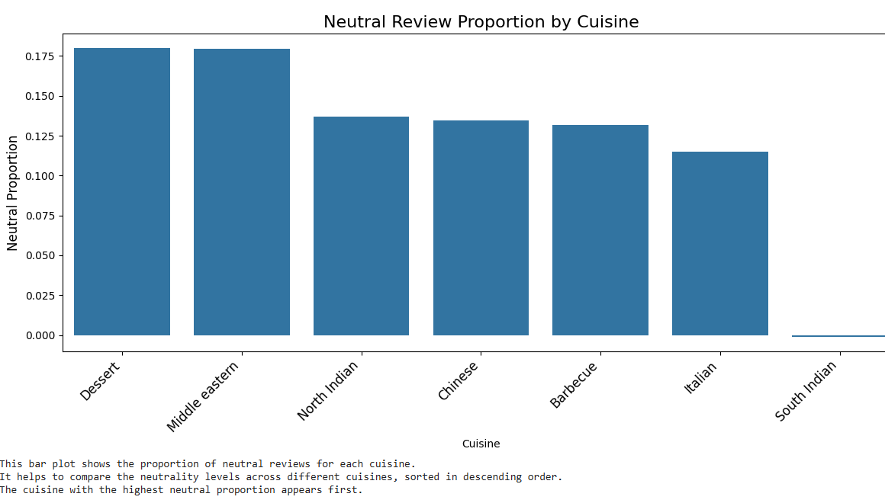

**4.Word Cloud**

**4.1 Italian Positive**

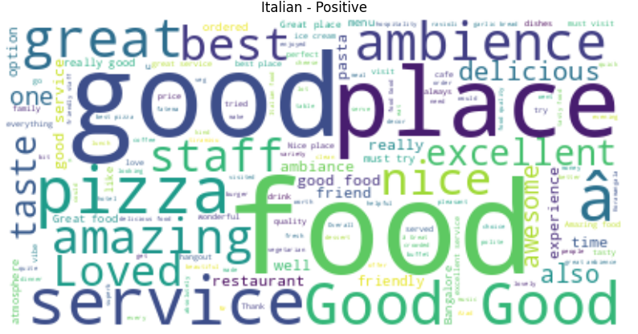

**4.2 Italian Negative**

**5.Key findings**

5.1 Overall sentiment distribution: Positive: 13401.072983792

Negative: 545.694358214

Neutral: 2357.8809

5.2 Cuisine with highest positive proportion: **South Indian**

5.3 Cuisine with highest negative proportion: **Chinese**

5.4 Cuisine with highest customer satisfaction (composite sentiment): **South Indian**

**Dilemma in the Case**

* **Problem Statement**: Despite the insight’s sentiment analysis can provide, certain challenges hinder the direct translation of sentiment data into actionable strategies:
  + **Sentiment and Rating Misalignment**: Some reviews display a mismatch between sentiment and ratings, where customers leave high ratings but provide neutral or even negative comments. This inconsistency complicates the interpretation of sentiment as a clear indicator of satisfaction. For instance, a customer may love the food (high rating) but express disappointment with service (neutral or negative sentiment), which can skew results if not carefully addressed.
  + **Cuisine-Based Sentiment Variability**: Different cuisines may be subject to unique biases. For instance, a high expectation for authentic flavours might make customers more critical of Italian or Mexican dishes compared to fast-food styles. Such biases make it difficult to generalize customer sentiment and satisfaction patterns across cuisines.
* **Key Dilemma**:
  + **Decision-Making Challenges**: Restaurant managers need to decide how to use sentiment analysis data effectively when sentiment doesn’t always align with ratings or customer expectations. Should they focus on cuisines with high positive sentiment to further strengthen these areas? Or should they prioritize addressing negative sentiments even if ratings are not critically low?
  + **Strategic Implications**: The dilemma of aligning sentiment-based improvements with actual customer needs raises questions about how much emphasis to place on each sentiment category. For example, should a restaurant with a high positive sentiment focus solely on reinforcing its strengths, or should it also address neutral or negative sentiment areas for a more balanced customer experience?

**Alternative Suggestions**

Here are three strategic approaches that restaurant managers could adopt based on sentiment analysis insights:

* **Alternative 1: Focus on Positive Sentiment Patterns**
  + **Approach**: Identify strong patterns of positive sentiment within each cuisine. For example, if Italian cuisine reviews show high positive sentiment for ambiance and food quality, the restaurant could highlight these aspects in promotions and make them the centrepiece of their dining experience.
  + **Pros**: By emphasizing what customers already appreciate, restaurants can build loyalty among their existing clientele and attract similar customer segments.
  + **Cons**: This approach may overlook pressing issues related to neutral or negative sentiments, potentially alienating customers dissatisfied with specific aspects (e.g., slow service).
  + **Best Fit Scenario**: This strategy is ideal for restaurants with predominantly positive sentiment and a strong alignment between high sentiment and high ratings, as it helps reinforce existing strengths and maintain customer satisfaction.
* **Alternative 2: Target High Negative Sentiment Areas**
  + **Approach**: Focus on reviews with significant negative sentiment, particularly for specific cuisines or restaurants where negative feedback is most prevalent. For example, if reviews reveal repeated complaints about the spice level in Thai cuisine, chefs could adjust recipes or allow customers to customize spice levels.
  + **Pros**: By directly addressing dissatisfaction areas, restaurants can enhance the overall customer experience and potentially turn negative reviews into positive ones, which can increase overall ratings and loyalty.
  + **Cons**: Requires more effort and resources, particularly if the negative sentiment involves structural issues (like long wait times) that may be harder to address in the short term.
  + **Best Fit Scenario**: This approach works best for restaurants with moderate to low ratings and a high volume of negative sentiment, as it directly tackles dissatisfaction points that could improve ratings and overall customer satisfaction.
* **Alternative 3: Balanced Approach with Composite Sentiment Analysis**
  + **Approach**: Use the composite sentiment score, which combines positive, negative, and neutral elements, to create a balanced view of customer feedback. This holistic approach helps restaurants identify areas where there’s a divergence between average sentiment and ratings. For example, if Italian cuisine has a high composite sentiment score but lower ratings, it may suggest customers have mixed or ambivalent feelings that warrant closer examination.
  + **Pros**: Provides a comprehensive view of customer feedback, balancing positive and negative aspects for a rounded customer experience strategy.
  + **Cons**: Composite scores can sometimes mask extreme sentiments, which may lead to less targeted improvements if negative or positive sentiments are diluted in the average.
  + **Best Fit Scenario**: This approach is best for restaurants where no clear positive or negative trend exists, and where there’s a desire for a balanced strategy that addresses both strengths and weaknesses in the customer experience.

**Best Practices for Implementing Sentiment Analysis**

While sentiment analysis can provide valuable insights, it's essential to follow best practices to ensure accurate and reliable results. Here are some key considerations:

* **Data Quality**: Ensure that the data used for sentiment analysis is clean, relevant, and representative of your target audience. Remove any irrelevant or spam data that could skew the results**.**
* **Context Understanding:** Consider the context in which the text is written. Sarcasm, irony, and idiomatic expressions can be challenging for sentiment analysis algorithms to interpret accurately. Manual review and validation may be necessary in some cases.
* **Domain-Specific Models:** Use domain-specific sentiment analysis models whenever possible. Different industries and topics may have unique vocabularies and expressions that require specialized models for accurate sentiment detection.
* **Continuous Monitoring:** Sentiment analysis should be an ongoing process rather than a one-time exercise. Continuously monitor sentiment trends and patterns to identify emerging issues and opportunities.

**Conclusion**

Sentiment analysis has proven to be a valuable tool for businesses across various industries. By leveraging the power of sentiment analysis, companies can gain deep insights into customer opinions, identify areas for improvement, and make data-driven decisions to enhance their products, services, and overall customer experience.

The case studies discussed here demonstrate the practical applications of sentiment analysis in customer feedback analysis. By following best practices and continuously refining their sentiment analysis strategies, businesses can unlock the full potential of this technology and stay ahead of the competition.

**Appendix**

**1. Data Summary and Description**

* **Detailed Dataset Description**: column in the dataset (restaurant name, review, Ratings, Collected by, Cuisine, Positive, Negative, Neutral, and Composite).
* **Data Sources**: Zomato
* **Data Preprocessing Steps**: Got the raw data from Zomato by scrapping and arranged and structured the columns according to our analysis

**2. Sentiment Analysis Methodology**

* **Sentiment Analysis Technique**: Used Text Blob for sentiment analysis.
* **Sentiment Scoring Breakdown**: Sentiment scoring is down based on the polarity from textblob.

**4. Additional Visualizations**

* **Sentiment Distribution Graphs**: Included histograms, pie charts, or bar charts that depict the distribution of positive, negative, and neutral reviews across different cuisines.
* **Word Clouds for Each Cuisine and Sentiment**: Full-size versions of word clouds for each cuisine/sentiment combination that were summarized in the main case study.

**7. References and Resources**

* **External Sources**: ChatGPT, Complete Guide of Sentiment Analysis for Data Analysis, Google, Kaggle, GitHub.
* **Libraries Used**: list of libraries and Python packages used in the analysis (e.g., pandas, matplotlib, Text Blob).

**Related questions**

Q1: What is the difference between sentiment analysis and emotion analysis?

Q2: Can sentiment analysis be applied to languages other than English?

Q3: How can sentiment analysis be integrated with other data sources?

Q4: What are some common challenges in sentiment analysis?

**Case Written By:**

1. Harish Gokul A